Junior Infant Booklist 2026/2027
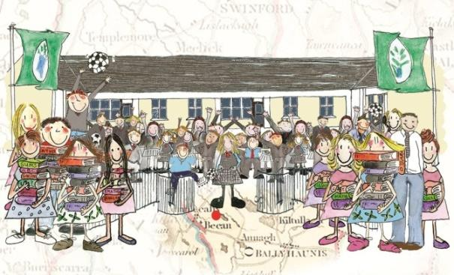

These items need to be purchased prior to starting school:
(This will all be kept in school so please purchase an alternative set for home use) | - 1 large school bag with separate drinks compartment (please make sure it fits an A4 size folder)  - 1 large pencil case  - A set of headphones  - 5 junior grip triangular pencils  - 1 eraser  - 1 sharpener that collects shavings  - 1 packet of Twistables (please label every twistable with your child’s name)  - 3 x large pritt stick  - 3 whiteboard markers  - 1 x A3 Carry case/folder (for art)  - 1 x safety scissors (left/right handed depending on your child)  - 3xA5 strong mesh zip folders  - 3xA4 strong mesh zip folders  - 1 colouring book for rainy days

- Please label everything that your child brings to school- pencils, jumpers, coats, hats, books, copies, folders, lunchboxes etc. I know this takes time, but it works well and avoids a lot of confusion.
- I hope that you all have a lovely summer and I’m looking forward to seeing you all soon!

_______________________________________________________________________
Email: bekanns@gmail.com Website: www.bekanschool.ie Twitter: @BekanSchool

