**Junior Infant Booklist 2025/2026**

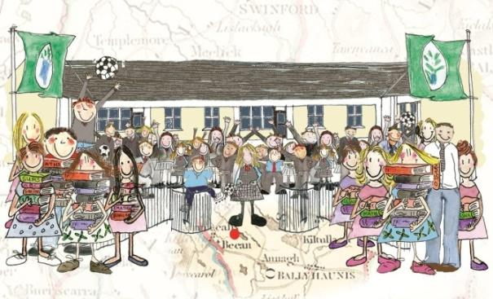

|  |  |
| --- | --- |
| **These items need to be purchased prior to starting school:** | |
| (This will all be kept in school so please purchase an alternative set for home use) | * 1 large school bag with separate drinks compartment (please make sure it fits an A4 size folder) * 1 large pencil case * A set of headphones * 5 junior grip triangular pencils * 1 eraser * 1 sharpener that collects shavings * 1 packet of Twistables (please label every twistable with your child’s name) * 3 x large pritt stick * 3 whiteboard markers * 1 x A3 Carry case/folder (for art) * 1 x safety scissors (left/right handed depending on your child) * 3xA5 strong mesh zip folders * 3xA4 strong mesh zip folders |

* Please label **everything** that your child brings to school- pencils, jumpers, coats, hats, books, copies, folders, lunchboxes etc. I know this takes time, but it works well and avoids a lot of confusion.
* I hope that you all have a lovely summer and I’m looking forward to seeing you all in September!

**_______________________________________________________________________**

**Email: bekanns@gmail.com Website: www.bekanschool.ie Twitter: @BekanSchool**