Ms. McGing’s 5th Class Booklist 2023/2024
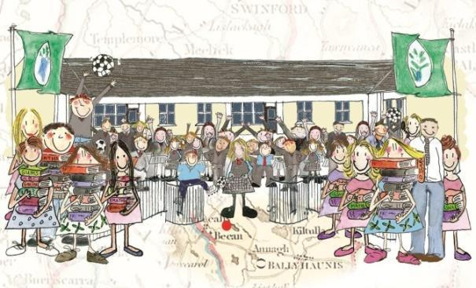

Subject | Publisher | Price
English
Reading Zone 6 Smart Ice-cream | Folens | €19.90
Exercise your English 6 | Edco | €12.50
Master Your Grammar 6 | CJ Fallon | €8.60
Swst Spelling Programme
Gaeilge
Bua na Cainte 6 | Edco | €19.95
Am don Léamh 6 | Folens | €8.05
Gleannta |  | €6.45
Mathematics
Planet Maths 5 | Folens | €22.90
New Wave Mental Maths 5  (Revised Edition) | Prim-Ed | €8.99
Figure It Out 5 | CJ Fallon | €11.75
S.E.S.E
Small World History | CJ Fallon | €16.20
Small World 6th Class – Geography and Science | CJ Fallon | €16.20
Just Maps 6 | educate.ie | €5.50
Other essentials to be bought:
Writing Copies x12 (88 page) | Red, blue and black biros
Maths Copies x 4 (88 page) | A calculator (not scientific) approx. €2
Nature Studies Copies x 2 | Pencil & eraser
1 Handwriting copy (B4 lines) | Ruler
White Board Markers | Tin Whistle (Key of D)
A4 Hardback Copy x3 | Colouring pencils/ twistables/
Large Pritt Stick/Tipp Ex | A4 Foolscap pad (with pull out pages)
2 Black Permanent Markers | Highlighter
1 A-3 Carry Case/folder (for art) | Mathematical Set (compass, protractor etc)
1 A-4 document folder | 1 A5 Hardback copy
Atlas | 1 Ring Binder (A4) not lever arch
80 Clear Poly Pocket Holders (for folder) | 10 subject dividers(for ring binder)
_____________________________________________________________________________________
Email: bekanns@gmail.com Website: www.bekanns.net Twitter: @BekanSchool

