Ms. O’Brien’s Junior Infant Booklist 2022/2023
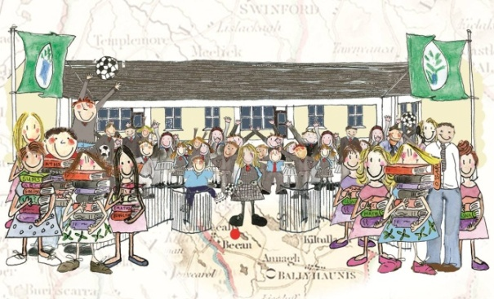

Subject | Publisher | Price
English
A Sound Beginning for Reading | C.J. Fallon | €6.25
Please note that Junior Infant readers will be provided by the school
Maths
Operation Maths A- Junior Infants Pack | EdCo | €14.25
Irish
Bua na Cainte A | EdCo | €10.95
Handwriting/ 6 Bricks
‘Handwriting Without Tears’ workbook , 6 bricks Lego Resource, 2x scrap books | €25- To be paid directly to the school- Details will be sent in September
Other Items to be bought:
Folders | - 1x A4 display folder with 60 pockets  - 3xA4 strong mesh zip folders  - 3 x A5 mesh zip folders
Copies | - 4x Blank/Plain day copies (40 pages)  - 1 x Junior Sum Copy (20 mm squares)  - 1x Junior Copy Book (15mm extra wide ruled)  - 3 x Project Book 15A (32/40 pages top blank)
Stationery | - 1 large pencil case (which will be kept in school)  - 5 junior grip triangular pencils  - 2 erasers  - 1 sharpener that collects shavings  - 1 packet of Twistables (please label every twistable with your child’s name)  - 3 x large pritt stick  - 3 whiteboard markers  - 1 large school bag ( please make sure it fits an A4 size folder)  - A set of headphones  - 1 x A3 Carry case/folder (for art)  - 1 x safety scissors
- Please label everything that your child brings to school- pencils, jumpers, coats, hats, books, copies, folders, lunchboxes etc. I know this takes time, but it works well and avoids a lot of confusion.
- Ensure that all books are covered in clear covering, with your child’s name clearly on the front outside cover
- I hope that you all have a lovely summer and I’m looking forward to seeing you all on August 30th
_____________________________________________________________________________
Email: bekanns@gmail.com Website: www.bekanschool.ie Twitter: @BekanSchool

