Ms. McGing’s 6th Class Booklist 2022/2023
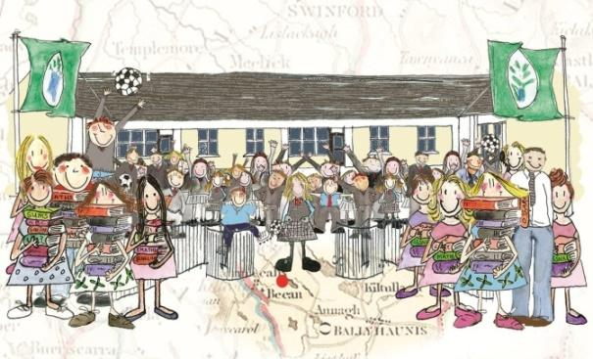

Subject | Publisher | Price | Rental
English
By the North Star | Edco | €17.80
Exercise your English 6 | Edco | €10.95
Swst Spelling Programme
Gaeilge
Bua na Cainte 6 | Edco | €22.00
Am don Léamh 6 | Folens | €7.60 | To be bought
Gleannta |  | €6.45
Mathematics
Planet Maths 6 | Folens | €18.40
New Wave Mental Maths 6 (Revised Edition) | Prim-Ed | €7.99 | To be bought
Figure It Out 6 | CJ Fallon | €10.00 | To be bought
S.E.S.E
Just Maps 6th Class | Educate.ie | €4.50 | To be bought
Small World History | CJ Fallon | €13.75
Small World 6th Class – Geography and Science | CJ Fallon | €13.75
Grow in Love 8 | Veritas | €15.00
Other essentials to be bought:
Writing Copies x12 (88 page) | Red, blue and black biros
Maths Copies x 4 (88 page) | A calculator (not scientific) approx. €2
Nature Studies Copies x 2 | Pencil & eraser
1 Handwriting copy (B4 lines) | Ruler
White Board Markers | Tin Whistle (Key of D)
A4 Hardback Copy x3 | Colouring pencils/ twistables/
Large Pritt Stick/Tipp Ex | A4 Foolscap pad (with pull out pages)
2 Black Permanent Markers | Highlighter
1 A-3 Carry Case/folder (for art) | Mathematical Set (compass, protractor etc)
1 A-4 document folder | 1 A5 Hardback copy
Atlas | 1 Ring Binder (A4) not lever arch
80 Clear Poly Pocket Holders (for folder) | 10 subject dividers(for ring binder)
________________________________________________________________________

