Ms. O’Brien’s 5th and 6th Class Booklist 2021/2022
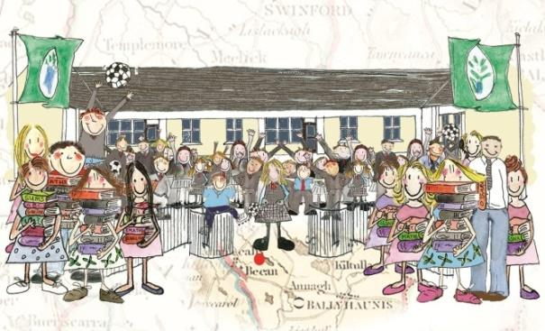

Subject | Publisher | Price | Rental
English
Racing Ahead! | CJ Fallon | €24.80
A Way With Words 6 | CJ Fallon | €12.12
Spellings for Me Workbook (includes workbook and online assessments) |  | €8.50 | Ordered through School
Gaeilge
Bun go Barr 6 | CJ Fallon | €22.90
Am don Léamh 6 | Folens | €7.60 | To be bought
Mathematics 5 for 5th Class 6 for 6th Class
Planet Maths 5/6 | Folens | €18.95
New Wave Mental Maths 5/6 (Revised Edition) | Prim-Ed | €7.99 | To be bought
Figure It Out 5/6 | CJ Fallon | €10.40 | To be bought
S.E.S.E.
Small World 6th Class – Geography and Science | CJ Fallon | €14.30
Religion
Grow in Love 6th Class | Veritas | €16.75
Other essentials to be bought:
Writing Copies x8 (88 page) | Red, blue and black biros
Maths Copies x 4 (88 page) | A calculator (not scientific) approx. €2
Nature Studies Copies x 2 | Pencil & eraser & ruler
1 Handwriting copy (B4 lines) | 1 Children’s Scissors
White Board Markers | 10 subject dividers(for ring binder)
A4 Hardback Copy x4 | Colouring pencils/ twistables
Large Pritt Stick | A4 Foolscap pad (with pull out pages)
Tipp Ex | Highlighter
1 A-3 Carry Case/folder (for art) | Mathematical Set (compass, protractor etc)
1 A-4 document folder | 1 A5 Hardback copy
Atlas | 1 Ring Binder (A4) not lever arch
80 Clear Poly Pocket Holders (for folder) | Ear phones (in ziplock bag/case)
Tin Whistle (D) | PLEASE BRING ALL BOOKS AND STATIONERY INTO SCHOOL ON FIRST DAY
_____________________________________________________________________________________
Email: bekanns@gmail.com Website: www.bekanschool.ie Twitter: @BekanSchool

