St.Joseph’s National School
Bekan

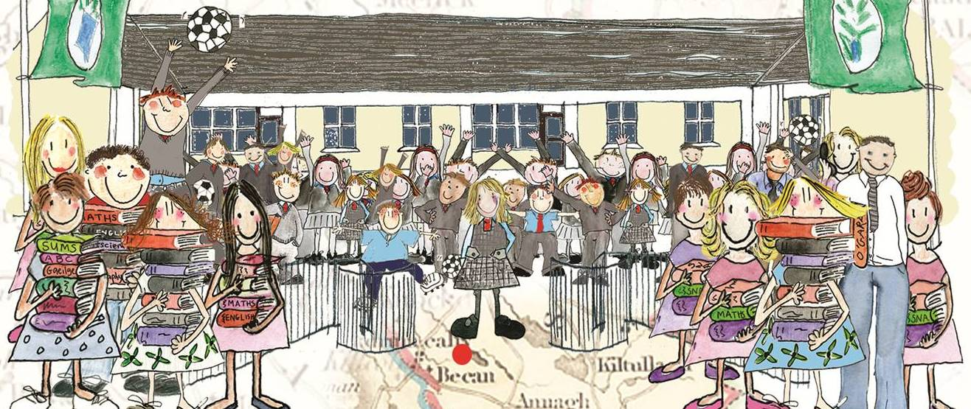

School Plan
for
Social, Personal & Health Education

School Plan in SPHE

Introduction
1. Our Vision for S.P.H.E.
2. Aims and objectives
3 Policies
4. Content of the plan
- Teaching/learning Content
- Teaching/Learning contexts
- Special needs/sensitivities
- Resources
- Approaches and Methodologies.
- Provision for Training and Staff Development
- Home/School/Community links
5. Success criteria / Assessment
6. Roles and responsibilities
7. Timeframe
8. Review and evaluation

Introduction
SPHE is a lifelong process and as such begins before the child comes to school. In this school we will provide a foundation that will inform the child’s actions and decisions and provide a basis for further development. Although it is a new curricular area we, in Bekan National School, have been teaching many elements of SPHE already. Below is a Whole School Review of S.P.H.E. carried out on Friday, 31 July 2026.

Current Provision in SPHE
- Many elements of the SPHE programme are currently being covered in the school through teaching of Religious programmes, Alive O and Children of God Series
- Stay Safe Programme and Walk Tall Programmes have already been introduced in the school
- Teachers endeavour to develop self-esteem and respect for others in all pupils attending the school both within the school, at play and in all school-related activities.
- Children are encouraged to participate in a variety of activities – Music, Drama, (School Concerts) Artistic, etc.
- A Code of Behaviour is in place in the school
- Environmental awareness is developed through other curriculum areas e.g. Nature and Environmental Studies

1. Our Vision for S.P.H.E.
Social, Personal and Health Education will provide opportunities for the individual child to develop a framework of values, attitudes, understanding and skills that will inform his/her decisions and actions now and in the future –enabling him/her to respect and relate to him/herself and others and become an active and responsible citizen in society. Its development is influenced significantly by the ethos and characteristic spirit of the school.
SPHE in our school should enable the child to develop and grow as a person and the effect of this should be evident in the child’s everyday interaction with their peers and the wider school community.

2. Aims and objectives
While seeking to meet the pupils’ needs, we will follow the aims and objectives of the S.P.H.E. Curriculum Statement pp. 9-10.
In addition, we emphasise the following:
Aims:
The aims of social, personal and health education are:
• to promote the personal development and well-being of the child
• to foster in the child a sense of care and respect for himself/herself and others and an appreciation of the dignity of every human being
• to promote the health of the child and provide a foundation for healthy living in all its aspects
• to enable the child to make informed decisions and choices about the social, personal and health dimensions of life both now and in the future
• to develop in the child a sense of social responsibility, a commitment to active and participative citizenship and an appreciation of the democratic way of life
• to enable the child to respect human and cultural diversity and to appreciate and understand the interdependent nature of the world.
(See page 9 of the Curriculum Statement)
Objectives:
(We acknowledge the objectives of the SPHE Curriculum as outlined on page 10 of the Curriculum Statement)
When due account is taken of intrinsic abilities and varying circumstances, the SPHE curriculum should enable the child to
• be self-confident and have a positive sense of self-esteem
• develop a sense of personal responsibility and come to understand his/her sexuality and the processes of growth, development and reproduction
• develop and enhance the social skills of communication, co-operation and conflict resolution
• create and maintain supportive relationships both now and in the future
• develop an understanding of healthy living, an ability to implement healthy behaviour and a willingness to participate in activities that promote and sustain health
• develop a sense of safety and an ability to protect himself/herself from danger and abuse
• make decisions, solve problems and take appropriate actions in various personal, social and health contexts
• become aware of, and discerning about, the various influences on choices and decisions
• begin to identify, review and evaluate the values and attitudes that are held by individuals and society and to recognise that these affect thoughts and actions
• respect the environment and develop a sense of responsibility for its long-term care
• develop some of the skills and abilities necessary for participating fully in groups and in society
• become aware of some of the individual and community rights and responsibilities that come from living in a democracy
• begin to understand the concepts of personal, local, national, European and global identity
• appreciate and respect the diversity that exists in society and the positive contributions of various cultural, religious and social groups
• promote the values of a just and caring society in an age-appropriate manner and understand the importance of seeking truth and peace.
3. Policies
The following policies related to SPHE issues have been drawn up/are being reviewed in consultation with parents, the Board of Management and other interested parties in the local community:
- RSE
- Substance Use
- Bullying in the context of our Behaviour/Discipline policy
- Enrolment
- A Statement on Child Protection (summarising the Government Guidelines and Reporting Procedures) We are adopting the National Guidelines for the Protection and Welfare of Children and the Department of Education and Science Child Protection Guidelines and Procedures.

4. Content of the plan
(i) Teaching/learning Content
Since SPHE is spiral in nature we will cover the following content at each level throughout the school over a two-year period: - [This will be subject to review and change where necessary]
Strands | Strand (Year 1) | Strand Units (Year 2)
Myself | Self-identity (Sept/Oct)
 |  | Taking care of my body (Sept/Oct)
 |  | Growing and Changing (Nov/Dec)
 | Safety and Protection (Nov/Dec)
 | Making decisions (Jan/Feb)
Myself and others | Myself and my family (Mar/Apr)
 |  | My friends and other people (Jan/Feb)
 |  | Relating to others (Mar/Apr)
Myself and the wider world | Developing Citizenship (May/June)
 |  | Media (May/June)

(ii) Teaching/Learning contexts
We will teach it in a combination of the following contexts:
A positive school climate and atmosphere and adopt strategies such as
- building effective communication within the school
- catering for individual needs
- creating a health-promoting physical environment
- developing democratic processes
- enhancing self-esteem
- fostering respect for diversity
- fostering inclusive and respectful language
- developing appropriate communication between home and school
- developing a school approach to assessment

Discrete time (time-tabled 1/2 hour per week or one hour per fortnight)
Children who are withdrawn for supplementary teaching must be included for as much as the SPHE programme as possible. This discrete time is used to develop and practice particular skills, deal with sensitive issues or explore issues that are not addressed in other areas of the curriculum. It has been agreed that content objectives dealing with RSE and child protection are addressed through discrete time.

Integration with other subject areas and Linkage within SPHE: (SPHE Teacher Guidelines pp. 31-33)
At each class level, teachers will seek to integrate SPHE with other curricular areas.
Teachers will endeavour to adopt a thematic approach to SPHE by integrating it with other subject areas such as Language, Geography, History, Religion, Visual Arts, Physical Education, etc. Themes/Projects such as Healthy Eating Week, Friendship Week, Healthy Heart Week, Lenten Campaign, etc. will also be explored.

(iii) Special needs/sensitivities
All staff members will need to be sensitive to particular Family circumstances, difficult situations etc. in the delivery of the SPHE Programme.
Children with learning difficulties may need to be shown particular consideration in certain areas of the programme.

(iv) Resources
Below is a list of resources available in school and for use in SPHE.
- Stay Safe Programme and Booklets for parents & CD
- Walk Tall Programme
- Code of Behaviour
- Information Booklet on the school for Parents
- Be Safe Programme
- Video and worksheets on various aspects of Safety – Electricity, Farm Safety, Water Safety
Other available resources:
- Health Book produced by the Western Health Board
- “Action for Life” ~ The Irish Heart Foundation
- Trocaire Materials: “Watoto” for Junior Classes; “Rafiki” CD Rom; “Games, Games, Games” [Book]
A comprehensive list of available resources and where they may be acquired is appended at the end of this policy statement.

(v) Approaches and Methodologies
We will adopt the following approaches and methodologies:
- Talk and discussion
- Skills through Content
- Collaborative learning
- Problem-solving
- Use of the Environment
- Active learning which includes drama activities, co-operative games, use of pictures, photographs and visual images, written activities, use of media and information technologies and looking at children’s work.

(vi) Provision for Training and Staff Development
In order to successfully implement this plan, the teaching staff have attended:
- training in the Child Abuse Prevention Programme(Stay Safe),
- training in the Substance Use programme (Walk Tall),
- training in the Relationships and Sexuality programme (R.S.E.),
- two full days in-service seminars in 2002-4 by the Primary Curriculum Support Programme
Circle Time will be used regularly in the delivery of the Programme at all class levels.

Individual teachers’ planning and reporting
The Curriculum documents and this school plan which describes the approach in this school to SPHE will inform and guide each teacher in his/her long-term planning in relation to each strand unit and short -term planning on a weekly basis
We will keep a cuntas míosúil in order to chart our progress in relation to work covered and in order to evaluate the teaching strategies and the suitability of resources. The information thus gathered will be used when reviewing and developing our Whole school plan and also when planning future work in the strand unit involved.

Further training and up-skilling will be needed in the following areas:
- SPHE provision for children with learning difficulties and/or low self-esteem.

5. Success criteria / Assessment
- A confident child, who respects others and is tolerant of differences.
- Independent child as regards decision making
- Responsible decisions taken by pupil.
- Pupils use their initiative in making decisions
- Feedback from parents and pupils
- Happy atmosphere in school

(a)Self- assessment
- Have I covered the agreed strand units?
- What do we need to change?
(b)Pupil assessment P. 70-77 [Revised Curriculum]
- Teacher observation
- Teacher designed tasks and tests
- Portfolios and pupil self-assessment
(c) Department of Education and Science/outside assessment

6. Children with different needs
All children with special needs are included and participate in SPHE with their own classes. Teachers will adapt and modify activities so that all children can participate. The learning support and resource teachers will supplement the work of the class teachers where necessary. Where feasible, the special needs assistant (SNA) will support the child in taking part in group activities and in the learning process.
We will deal with specific sensitive issues such as bereavement or loss, disability, illness by supporting the person involved as much as possible. This may also entail supporting other children in the school community.
Our school makes every effort to be aware of and sensitive to the cultural differences of the children in our care.
7. Equality of participation and access
We celebrate diversity in this school community. We believe that we all have the same basic needs but different ways of getting our needs met. All children have access to services, facilities or amenities in the school environment.
Our school is under Roman Catholic school management. Ours is a mixed sex school. We use inclusive language at all times and both male and female roles and viewpoints are included as much as possible. With regard to RSE the changes at puberty for both boys and girls are taught as per our RSE policy.

8. Homework
SPHE homework, if prescribed, will reflect the active learning approach as described in the curriculum. Children will be given tasks that involve seeking information or reinforcement of class based learning.

12. Parental involvement
We welcome the contributions of parents in the development and implementation of SPHE in this school. Parents are informed of the school’s programme for SPHE through the school information booklet and through this school plan. The SPHE curriculum documents are available for inspection in school. Parents are involved in drafting and reviewing school policies such as Substance Use, Relationships and Sexuality Education.
An active Parents Association supports the work of the School through their involvement in many aspects of the running of the school both organisational e.g. fundraising; assistance with school projects, concerts, Sacramental Preparation and also curricular areas e.g. Policy Development in areas such as SPHE, Substance Use, Internet Usage, Healthy Eating etc.
13. Community links
We are aware of the vast amount of expertise and skills in our local community and welcome the support of members at all times.
The services of the Child Abuse Prevention Programme [CAPP] are availed of in the ongoing training of both staff and parents in this area.
Board of Management members are encouraged to attend training programmes for Boards of Management by CAPP.
9. Roles and responsibilities
We, the principal and teaching staff, believe that SPHE is a shared responsibility between family, school, health professionals and the community. We see ourselves supporting the home in this lifelong process and will seek at all times to develop positive relations with all these parties.
The Principal in consultation of the rest of the staff will co-ordinate the progress of the plan, encourage and accept feedback on its implementation and report to staff on findings.
10. Timeframe
The staff will endeavour to implement the SPHE curriculum comprehensively before the pupils graduate in Rang 6.

11.Review and evaluation
The staff will review this plan and related policies in June every two years.

12. Review and evaluation
This school plan was reviewed by the principal, staff on 9th February 2016 and approved by the Board of Management of Bekan N.S. on _____________________

Chairperson of the Board of Management_____________________________________

