St. Joseph’s N.S.
Bekan

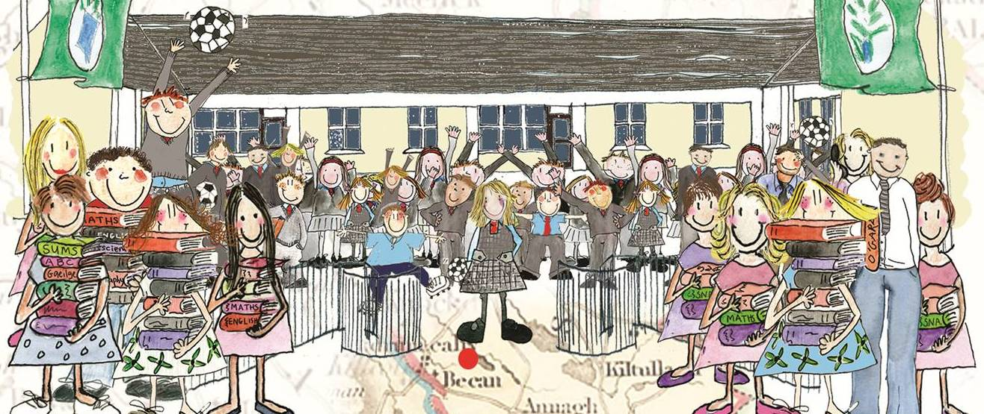
Pupil Profiling/Reporting Policy

Policy on Pupil Profiling / Reports on Pupils

Introduction

This policy was the product of whole-staff collaboration in tandem with the Parents Association and The Board of Management of Bekan National School.

Rationale

The need for this policy arose from –

- Section 22. 2(b) of the Education Welfare Act which requires schools to regularly evaluate students and periodically report the results of the evaluation to the students and their parents
- Section 9 (g) of the Education Act which ordains that parents of a student have access in a prescribed manner to records kept by the school relating to the progress of that particular student
- The need to engage with the terms of Primary Circular 14/04 in relation to reporting to parents.

Relationship to School Ethos

The mission of the school encourages the active involvement of parents through positive home-school contacts and through the activities of an active Parents Association. This policy reflects the above.

Aims and Objectives

- To assist and evaluate the social, personal and academic development of the pupil body
- To record and update these developments during the Primary School Cycle through the drawing up of an individual Pupil Profile updated annually
- To identify areas / aspects of a child's development which may require attention / remediation
- To update all parents / guardians on the progress of their child in his / her education
- To provide parents / guardians with access to any permanent records relating to their child’s progress.

Assessment
The primary source of assessment is that of teacher contact in the classroom and is initially based on informal assessment. Formal and continual classroom assessment is then introduced through the use of standardised testing-(Sigma/Micra) and the use of M.I.S.T, N.R.I.T and other specific testing procedures. Pupils over 6 who fail to respond to stages 1 and 2 of the intervention procedures outlined in Circular 02/05 are referred to an Education Psychologist. A record of each child’s performance in formal tests is maintained in that child’s individual Pupil Profile and is passed from teacher to teacher as the child progresses through the Primary Cycle.

Reporting to Parents

The school reports to parents through an-end-of-year report card and an annual parent – teacher meeting (held in October/November).

Informal reporting is also carried out though the use of the child’s homework dairy and the issuing of circulars and notes to individual parents / guardians if an issue concerning their child arises. The end of year report is given in written form.

Parents are also welcome to visit the school at any time to discuss their child’s progress. These visits are by appointment only through the school secretary. The school endeavors to report to both parents in the event of marital breakdown but does not report to the partner of a separated parent. The school will initiate emergency meetings with parents if behavioural patterns, attendance or other concerns warrant such meetings. Where there are serious concerns re behaviour it is school policy to have two teachers present.

Parent – Teacher Meetings

A parent-teacher meeting is held once a year, commencing at 3.00pm on a designated day. Each teacher will have prepared notes on each child incorporating class test results, standardised test results, homework, progress, special talents, etc. This meeting is normally scheduled for October / November of each year. Each parent / guardian is given a specific appointment time in advance. Special arrangements and dovetailing of appointment times are arranged for parents who have children availing of Learning Support / Resource or who have more than one child in the school.

The Principal is available to meet individual parents on parent-teacher day with a prior appointment.

Teachers will generally provide parents with information and guidance on educational progress, homework, test results, social development, behaviour, application, SEN, talents, attendance etc at a parent-teacher meeting.

End of Year Report Cards

The school provides an end of year report card to parents.
St. Joseph’s National School, Bekan use one of the report card templates (available at www.ncca.ie) for reporting to parents on students’ progress and achievement at school. The report cards provide for reporting in four key areas:

• The child’s learning and achievement across the curriculum
• The child’s learning dispositions
• The child’s social and personal development
• Ways in which parents can support their child’s learning

School reports are mailed to parents one week before school closes for Summer holidays. This is to give parents an opportunity to consult with the class teacher if there are any problems, queries etc. All reports are photo-copied and held in each child’s individual pupil profile folder, and passed on at the beginning of each new school year.
Records are stored until pupils reach the age of 21 years. In the case of children with Special Educational Needs, records are stored until they reach the age of 24 years.

Homework

The school operates a policy of giving appropriate homework to each class with a defined time limit. Homework can be a very useful means of keeping lines of communication with parents open whilst at the same time reporting on a pupil's progress. The school has a comprehensive Homework Policy which is available to all parents on request.

Attendance
Patterns of attendance for each pupil are recorded on report cards and pupil profiles. All notes from parents relating to pupil absences are dated and retained in the Secretaries office and all parents/guardians are made aware of the N.E.W.B guidelines in relation to attendance.

Please Note – the prior written consent of parents is required by the school where outside agencies are seeking a report on a child. This applies in custody cases and / or access cases. Prior written consent in the event of a case involving child abuse is referred to the BOM.

Roles and Responsibilities

All parents, staff, BOM, PA and pupils have a role to play in the successful and on going implementation of this policy.

Success Criteria

- Open lines of communication with parents
- Increased awareness of pupil progress and early identification of needs
- Staff, pupil and parental satisfaction
- Optimum achievement for pupils.

Review: This policy will be reviewed in 2019

Ratification and Implementation:
This policy was ratified by the Board on ____________________

Signed on behalf of the Board of Management:

Chairman: ________________________ Date: __________

Principal: _____________________ ___ Date: ___________

References

- Education Welfare Act 2000
- Education Act – Section 9g and Section 22
- CPSMA Handbook

