St. Joseph’s National School
Bekan, Claremorris, Co.Mayo

Phone: 094-9380311 E-mail: bekanns@gmail.com

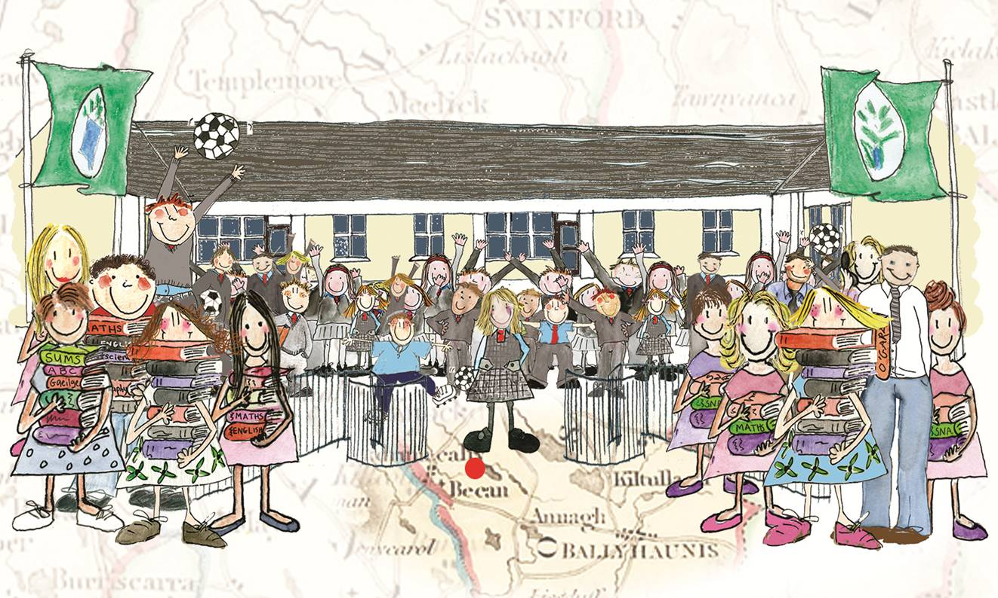

Information Booklet

Vision Statement
“St. Joseph’s N.S., under the patronage of the Catholic Archbishop of the diocese of Tuam, is committed to enabling and assisting all students and staff to achieve their full potential in an atmosphere of mutual co-operation while respecting all differences of ability, culture, race or language.”

The purpose of this booklet is to familiarise parents with school routines and procedures. The content of this booklet has been formulated, taking into account;
- Guidelines issued by the Dept. of Education and Skills
- Professional expertise of Principal and Staff
- Input by school BOM, of which two are members elected by the parents of pupils attending the school
- Contributions of parents through the School’s Parents’ Association.

Aims of the school
The aims of the school are briefly stated as follows

- To enable the child to live a full life as a child.
- To equip him/her to avail of further education so that he/she may go on to live a full and useful life as an adult in society.

Please take some time to read the school rules (see code behaviour) with your child. Help him/her to understand and realise that the rules make sense and that they exist for reasons of safety and good order in the school. The rules are necessary in order that an excellent learning environment can be fostered and maintained.

School Ethos

We endeavour to cater for the full and harmonious development of each child attending this school. While the religious beliefs of all children attending this school are respected, the School is under the patronage of the Archbishop of the Tuam Diocese and Catholic Religious Instruction is an integral part of the school curriculum. [See Enrolment Policy]

Co-operation between parents and teachers cannot be stressed often enough. The importance of the contribution of parents to the overall education of the child cannot be overstated. We value your opinion and look forward to your enthusiastic participation in the life of the school. Bekan School has a very active Parents’ Association and they are a wonderful support to the school. We have the same aim: to enable your child to develop his/her natural powers at his/her own natural rate to his/her fullest capacity.

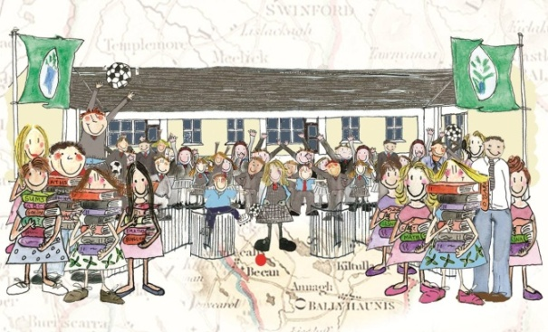

What St. Joseph’s N.S.,Bekan, can offer your child!

- A Committed Staff
- Favourable Class Size
- Comprehensive Learning Support & Resource Programmes
- Standardised Attainment Testing in Literacy, Numeracy, Irish and Spellings
- Each classroom Computer and Internet/ Broadband equipped
- Laptops for all classes (timetabled)
- Digital School of Distinction
- Book Rental Scheme
- Successful School Football Teams
- Well-stocked Class Libraries
- School Choir and Participation in Children’s Masses
- Concerts/Quizzes
- Tin-Whistle /Accordion/ Violin tuition as part of our music curriculum
- Swimming Lessons
- Discovery Primary Science and Maths programme
- School Tours/ Day Trips
- Shared Reading Programme
- Literacy Lift-Off Programme
- Board of Management and active Parents’ Association
- Green School Programme- St. Joseph’s have been awarded 4 Flags to date
- Junior Entrepreneur Programme (Seniors)
- Blue Flag Programme (Seniors)
- CraftEd Programme

1. School Assembly and Dismissal
Assembly time is 9.30 a.m. The school will open to receive children at 9.20 a.m. No responsibility is accepted for pupils arriving before this time. Games are not permitted at this time or at dismissal time. Dismissal time is 2:10 p.m. for Infants and 3.10 p.m. for all other classes. Parents, whose children do not travel to or from school by school bus, should arrange to have their children met at the school gates by the person appointed to escort them home. This person should be at the school no later than 3:20 p.m. as the school cannot accept responsibility for looking after the children after this time.

2. School Uniform
St. Joseph’s school uniform is as follows; grey v-neck jumper, grey trousers/skirt & socks, pale blue shirt/blouse and red tie. All pupils must wear their school uniform.
The School P.E uniform is; plain navy tracksuit and light blue polo shirt to be worn on Swimming/P.E. days or as may be advised from time to time by the teacher. Please note hoodies are not allowed for safety reasons. Suitable footwear should also be worn. Many types of footwear are unsuitable for school wear, as they are often bulky and create a tripping hazard for children.

3. Absences
A written note is required for all absences of children from school. Homework journals have a section at the end especially for this purpose. The absence notes must be kept in the school. A note, signed by the parent, will be required if somebody other than the parent is collecting a pupil from school for an appointment.
If you are taking your child out of school for an extended period, please communicate directly with the teacher. Your child will miss valuable teaching time when absent. Please note new regulations under the Education Welfare Act in respect of taking children out of school. All absences of 20 school days in any school year must be notified to the ‘Tusla’ by the school authorities [regardless of the reasons for absence].

4. Accidents
In the event of injury at school, wounds are usually washed with water only. If your child comes home with a dressing on a wound, please remove it, clean the wound and give further attention. If your child sustains an injury that requires stitching or other medical attention, we will contact you and ask you to take the child home. Please refer to the section on the enrolment form that refers to arrangements for contacting parents (or persons nominated by the parents/guardians), who may take charge of the child. Please ensure that there will be somebody available to take charge of the child in the event of the parent being absent from home. These arrangements should be monitored daily and parents should ensure that one of the nominated persons is available in the event of a mishap or in the event of the school having to close unexpectedly owing to unforeseen circumstances). We will also contact you if, in the opinion of the teacher/principal, your child is not sufficiently well to remain in school for the remainder of the day.

5. Medical Conditions
Please ensure that the school is notified of any medical conditions etc. that your child may suffer from (See section on enrolment form re. Relevant information and also the Statement on the Administration of Medicines which is available on website) Please contact the school’s Board of Management if your child has any medical condition that requires the administration of medication during school hours.
A child should never have medicine in their possession in school.

6. Special Education Needs
The school currently has access to the services of the National Educational Psychological Service [NEPS] and every effort will be made to make psychological assessment available to pupils where it is considered necessary. As a result of the most recent departmental provision for learning support, this school now has one full time Resource Teacher, one full-time Learning Support Teacher and a shared Learning Support Teacher [5 hours per week]. If a child experiences learning difficulties in class, the teacher will bring this to the attention of the parents at the earliest possible opportunity.
For parents of children attending the school the first time, please notify the school of any special requirements or considerations in relation to your child as early as possible, so that the necessary supports or services may be sourced and put in place.
The National Council for Special Education now has responsibility for the provision of services to children with Special Education Needs. Those needs may be identified by means of an assessment carried out by an educational psychologist, speech therapist or other health-care professional. Application must be made to the local Special Education Needs Organiser [SENO]. The SENO makes a decision regarding the necessary services and arranges with the School for their provision where a child qualifies for such services.

7. Assessment and Reporting to Parents
The school carries out regular assessments across the curriculum. Standardised testing in literacy and numeracy are carried out in all classes from 1st to 6th on an annual basis.
The Micra-T and Sigma-T literacy and numeracy tests are administered from 1st to 6th class.
The Belfield Infant Assessment Profile and Test2R are used in Junior Infants and the Middle Infant Screening Test in Senior Infants. The Non-Reading Intelligence Test [NRIT] is administered to pupils at 2nd Class level in early February annually.
Standardised Spelling and Irish tests are also administered at the end of the school year from 2nd -6th class. Please refer to Pupil Profiling/Reporting & Assessment Policies available on website for further information.
The results of those tests are communicated to parents at parent/teacher meetings and also by written report at the end of each school year. At the end of the school year the school is obliged to forward the results of standardised tests in literacy and numeracy to the DES.
The school has adopted the NCCA [National Council for Curriculum and Assessment] guidelines in communicating written reports to parents.
St. Joseph’s N.S. also encourages pupils to participate in Youth Academy programmes in NUIG
Teacher designed tests are used in other Curricular areas on an ongoing basis.

8. Parent/Teacher Meetings
Individual Parent/Teacher meetings are held annually, usually before the end of Oct. Each parent will be given an appointment a few days in advance of these meetings. On these days children are usually dismissed from school at a slightly earlier time. In accordance with Dept. of Education guidelines, those meetings will be held after school hours. A report on your child’s progress in school will be provided at these meetings.

9. Social, Personal & Health Education [SPHE]
A Relationship and Sexuality Education programme will be implemented in the school as part of the overall SPHE programme. This programme has input from Board of Management, Parents and Teachers. Parents will be afforded the opportunity to familiarise themselves with the content of the Programme prior to its delivery to the children.
An outside experienced facilitator will be employed to assist in the delivery of the more sensitive sexual areas of the programme in the senior classes. As a parent/guardian, you will have the right to view the content of the programme. Parents may decide to exclude their child/ren from this part of the SPHE programme, in which case they assume personal responsibility for the delivery of this aspect of their child’s education.

10. Movement on school grounds
Pupils are expected to assemble at the school and exit from the school in an orderly manner, using only the entry and exit points designated by the school principal and teachers. Pupils are expected to exercise caution when entering and exiting school grounds and when boarding buses. Pupils should never cross gates or walls or walk along boundary walls while entering or exiting the school grounds.

11. Parking
Vehicles are not allowed inside the school gates. Exception may occur in the case of emergency services, delivery of heavy materials to the school etc. In respect of loss or damage to the vehicle it should be remembered that the Board of Management does not make any charge in respect of parking and therefore does not undertake to safeguard the vehicle. Cars parked on the school grounds, therefore, are at owners’ risk. Parents are also requested to avoid causing obstruction to the free movement of buses, and in particular not to park in such a way as to block access to the school. In general, all those involved in transporting children to the school should park only on the school side of the road and to leave the parking area marked ‘BUS ONLY’ free for the school buses at school assembly and departure times. An adult should escort first-time pupils, who come to school by car, to and from the classroom or the school gates.

12. Information/Communication
All information/communication or anything of a sensitive or confidential nature between school and home should be sent in a sealed envelope showing pupil’s name, teacher’s name and a brief reference to the enclosed material where appropriate.
Information on the running of the school is communicated to parents through quarterly newsletters, website, text message and twitter. Please visit our website @ www.bekanns.net or follow us on Twitter @BekanSchool for up to date information. Please ensure that you provide the school with a mobile phone number in order to receive relevant messages. If the phone number is changed it is your responsibility to notify us in writing.
Parents may email the school @ bekanns@gmail.com

13. Breaks
Mid-morning; 11:00-11:10 a.m.
Main lunch break; 1:00-1:30 p.m.
Normally, it is expected that a child who is well enough to come to school is well enough to go out to play at break times. A note is required if, for some exceptional reason, a child needs to remain inside during those times or if he/she needs to leave school early. Please ensure that your child has suitable clothing depending on weather e.g. hat, coat, gloves etc. during wintertime.

14. Healthy Eating
It is important that your child has a nourishing lunch in school. We actively encourage healthy eating and, for this reason, crisps, chewing gum, sweets, chocolates or fizzy drinks are not allowed in school. As part of the school’s healthy eating policy, parents are encouraged to include foods which are known to promote good health e.g. bread, fruit etc.
As the School has Green School Status, the use of re-usable plastic lunch boxes and bottles, rather than disposable cartons, wrappers etc. is encouraged to reduce the amount of litter produced in the school.

15. Health Concerns
We ask all parents/guardians to be vigilant in checking for common problems that affect school-going children, e.g. Head-lice, any form of rash, infection etc. and to inform the school immediately.
While we encourage regular attendance, a child who is clearly unwell will not benefit by being in school. Under no circumstances should a child be in possession of any kind of medicines or prescription drugs when coming to school. If a child is unwell he/she should not be in school. Children cannot be kept in classrooms during break times as no supervision is available in the classroom once the children have finished lunch. Some children may need to have medication administered on a long-term basis for a chronic or ongoing medical condition e.g. asthma. In all such cases, the parents/guardians of the child should contact the school Board of Management to see if suitable agreed arrangements can be put in place to facilitate the administration of such medication. No teacher may administer prescribed medicines to any pupil except on the authorisation of the Board of Management. The parents/guardians of the child may be requested to sign an indemnity form where a member of staff has agreed to carry out the administration of such medicines. This requirement may only be arranged in consultation with the Board of Management and a teacher may only administer medication at the request of the Board. (A separate policy on Administration of Medicines has been drawn up and is available on our website)

16. Home/School Contact
If your child is unhappy or encountering problems in school, please feel welcome to come and discuss the matter, first with the class teacher. Please make an appointment with the teacher in advance by phoning the school secretary at 094-9380311 or email bekanschool@gmail.com

17. Appointments with Principal
In general, any communication regarding the child should be first addressed to the class teacher. Because of the administrative workload attaching to the duties of a teaching principal, it is necessary to make an appointment for consultation with the Principal. Please contact the school secretary [as above] in this regard.

18. Homework Policy [Summary]
It is impossible for a teacher to give homework that is equally suitable for all children in a large, and frequently mixed, class situation. Some children can finish work in a relatively short time while others struggle on for much longer.
Nobody wants children to be unnecessarily pressurised by homework, nor do we wish homes to be upset by this pressure. At the same time we do not want parents to be deprived of a valuable form of parent/school contact and the opportunity to participate and play an important role in the development of their child’s educational progress. Homework also provides children with the opportunity to revise and consolidate the work that they have been doing in school. It is also desirable that a child would have experience in studying independently prior to progressing to second level education, as this will be an essential skill at this stage.
Clearly, a compromise is required. We rely on parents to decide, if a child is experiencing difficulty, when the child has spent enough time at homework. A short note in the homework journal will suffice to indicate that a genuine effort was made. Always communicate with the class teacher if your child is experiencing persistent difficulty with homework.

The following summary of the school’s homework policy guidelines, drawn up in consultation with parents, may be of help. [Policy available on request]

- Give the child some time to relax and play after school
- Have a designated period for homework
- Turn off the T.V. during homework time.
- Sign the homework notebook when the work is finished (Check that the homework was written down and completed. Journals should be signed at least weekly in the case of senior students, and more frequently in the case of junior students.)
- Look for any comments from teacher from previous day/week
- Homework is not only given in written form. Memorisation e.g. spellings, tables etc. is also very important.
- Attention to neatness and presentation is important.

19. Mobile Phone Use
Students are not normally permitted to carry mobile phones in school or use the school phone. A member of the school staff will contact parents or convey messages from parents to children if necessary. Exceptions to this rule may be made only at the discretion of the Principal or a designated Staff Member.
If mobile phones are found in children’s possession, they will be confiscated and returned only to parents.

20. Complaints and Enquiries
For all general enquiries regarding the school: - Contact school secretary.
Any enquiries in relation to specific children or teachers should be addressed in the following manner:
- The parent should approach the class teacher and discuss the complaint, query etc.
- If the matter is not resolved following this consultation, the teacher and parent will consult the school principal.
- Should the matter require further attention, following consultation with the Principal, a meeting may be arranged between the above parties and Chairperson of the Board of Management. A formal complaint should be presented to the Board in writing and any complaints, involving hearsay or other individuals, will not be considered by the Board.

21. Child Protection
Under the Education Act, all schools are required to follow the Children First Guidelines on Child Protection as laid down by the DES (Dept. of Education and Skills). Designated Liaison persons (generally School Principals) and Deputy Liaison persons are appointed in all schools. They have the responsibility to report suspicions of abuse of children to the relevant authorities (normally the HSE Social Services Dept.). A letter outlining these procedures will also be attached to this booklet for parents of future first-time pupils. The Guidelines outline the procedures to be followed by teachers in relation to the reporting of suspected child abuse. The full text of the Children First guidelines are published on the HSE website http://www.hse.ie/eng/services/Publications/services/Children/cf2011.pdf
A letter outlining the school’s obligations under Child Protection legislation is issued to all parents on enrolment of children. Parents are asked to sign and return the relevant section of the letter.
The Principal must provide a report at each Board of Management meeting, informing the Board as to whether any report has been made to the HSE in relation to child protection issues or if any advice has been sought in this regard.

22. Behaviour
We ask the co-operation of parents in implementing the code of behaviour as effectively as possible. A clear understanding of the code and the need for its existence is important for all pupils. [See Code of Behaviour and Anti-Bullying Policy included with this booklet for parents of new students] In light of recent technological developments and the rise in the growth of social media and communications, the issue of online or ‘cyber bullying’ has given rise to problems, particularly for parents of teenage or pre-teenage children. For this reason, social networking sites such as Facebook etc. are not allowed on the school’s internet service. Likewise, sites which permit users to publish personal data such as YouTube are disallowed under the service. Parents are asked to be vigilant with regard to cyber bullying as many children routinely use smartphones which also give access to these services and are much more difficult for parents to monitor or supervise outside of school time.

23. School Transport
Bus Éireann provides transport to children living within the school catchment area. Further information on entitlement to this transport is available from the School Transport Section, Bus Éireann, Ballina, Co.Mayo.
While the supervision of behaviour and related matters on school buses is primarily a matter for the transport providers, the school actively encourages and promotes an awareness of the need for responsibility, respect and personal safety among students travelling to and from school. Children who travel to school by bus should be encouraged, from a very early stage, to follow safety guidelines e.g. boarding the bus in an orderly manner, sitting in their seats while the bus is in motion, wearing seat belts at all times, avoiding any unruly behaviour likely to distract the bus driver, crossing the road carefully etc.

24. Alternative arrangements for collecting children
It is very important to notify the school if your child is being collected by someone other than the person who would normally collect him/her e.g. at home time, for dental/medical appointments or other. The school should also be aware of any person[s] who should not have access to the school e.g. by court order or other legal requirement.

25. Development of School Policy
In consultation with Management, Parents & Staff a number of policy statements have been drawn up dealing with various curricular and organisational aspects of school life and have been ratified by the Board of Management. These are reviewed and amended as required to take account of changing circumstances, changes in legislation or other requirements. Copies of these are available to all parents/guardians of children enrolled in the School from the School on request or downloaded from our website. [See list of main areas below].

- Curricular
  - Policy Statements relating to Curricular Subject areas; English, Irish, Maths, Physical Education, , SESE, [Social, Environmental and Scientific Education], Music, Visual Arts, SPHE [Social, Personal and Health Education] & RSE [Relationships and Sexuality Education]
  - Recording and Assessment
  - Special Education Needs and Learning Support
  - School Self Evaluation Report
  - School Improvement Plan

- Organisational ~ Main areas include e.g.
  - Administration of Medicines
  - Anti-Bullying Policy
  - Assessment and Recording policy
  - Attendance Policy
  - Book Rental Policy
  - Child Protection Policy
  - Class Allocation Policy
  - Code of Behaviour
  - Data Protection Policy
  - Emergency Closures Policy
  - Enrolment Policy & Enrolment Form
  - Equality of Opportunity
  - Health & Safety
  - Healthy Eating
  - Information & communications technology skills
  - Information Booklet
  - Internet Acceptable Use
  - Internet Safety Guidelines
  - Job-Share Policy
  - Mobile Phones
  - Parent and Staff Communication Policy
  - Pupil Profiling and Reporting
  - School Transport Code of behaviour
  - Substance Use
  - Supervision
  - Swimming Lessons – Guidelines
  - Tips and advice for new entrants
  - Use of School by Outside Agencies

The Staff, Board of Management and Parents’ Association of St. Joseph’s N.S. are very dedicated and committed to enabling each and every pupil to live a full life as a child and to become equipped to live a full life as an adult. We welcome your input as partners in the role of educating your child and would encourage you to become involved in the Parents’ Association and Board of Management.

